الاسم:عمر محمد محمود حسنين (2)
Chapter 2
1) 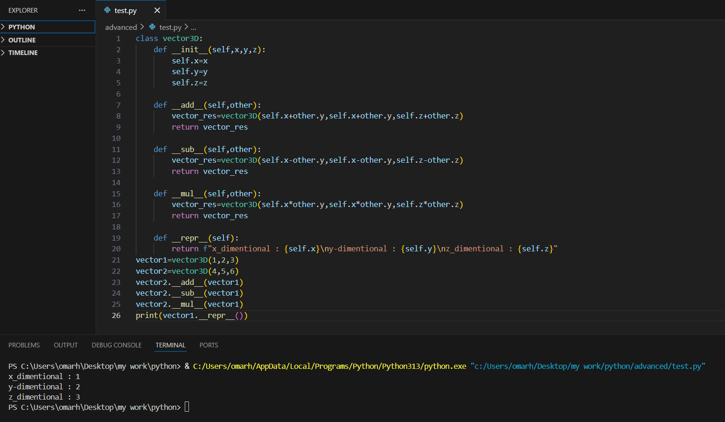

2) 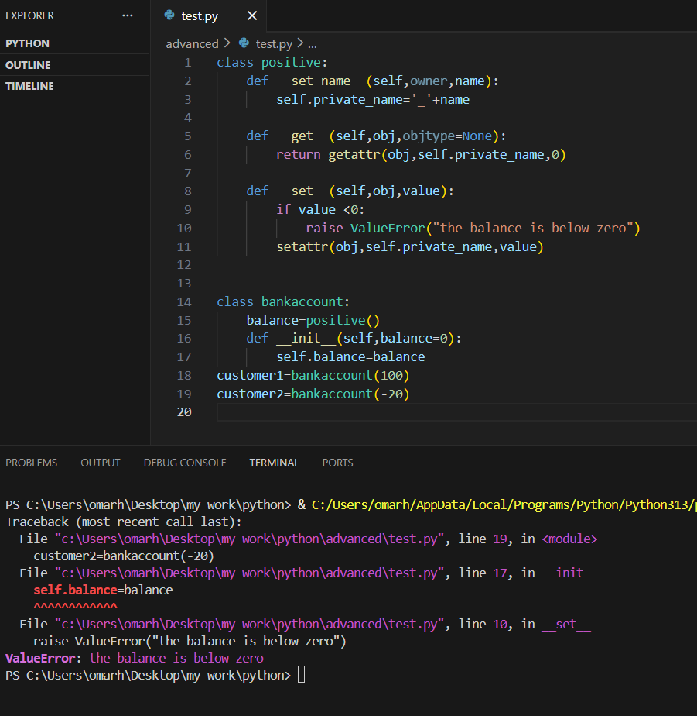

3)when using slots it prevents and object from add a new attribute that isn’t present in the class slots definition.
